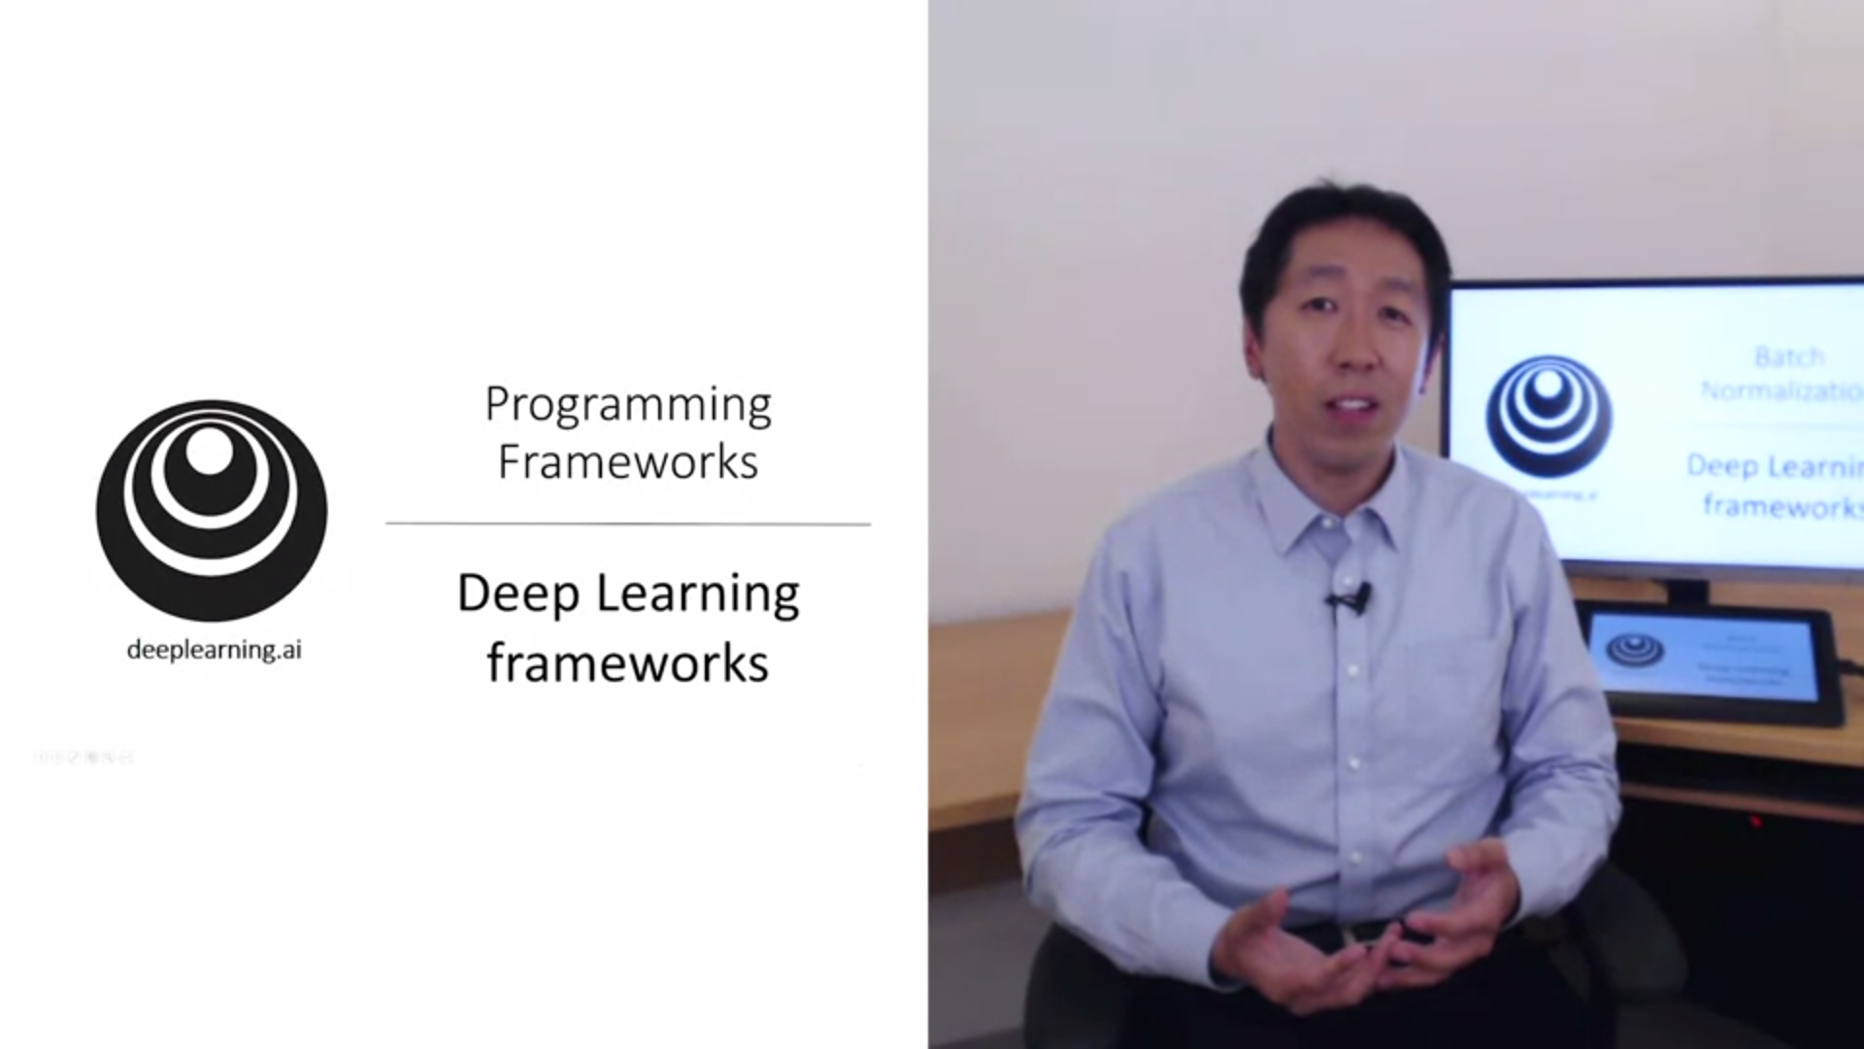

Deep learning frameworks make us much more efficient at implementing algorithms. But it was still important to understand everything in numpy and standard python. This is what the frameworks are doing under the hood.

Do not reinvent the wheel. Deep learning has matured enough.

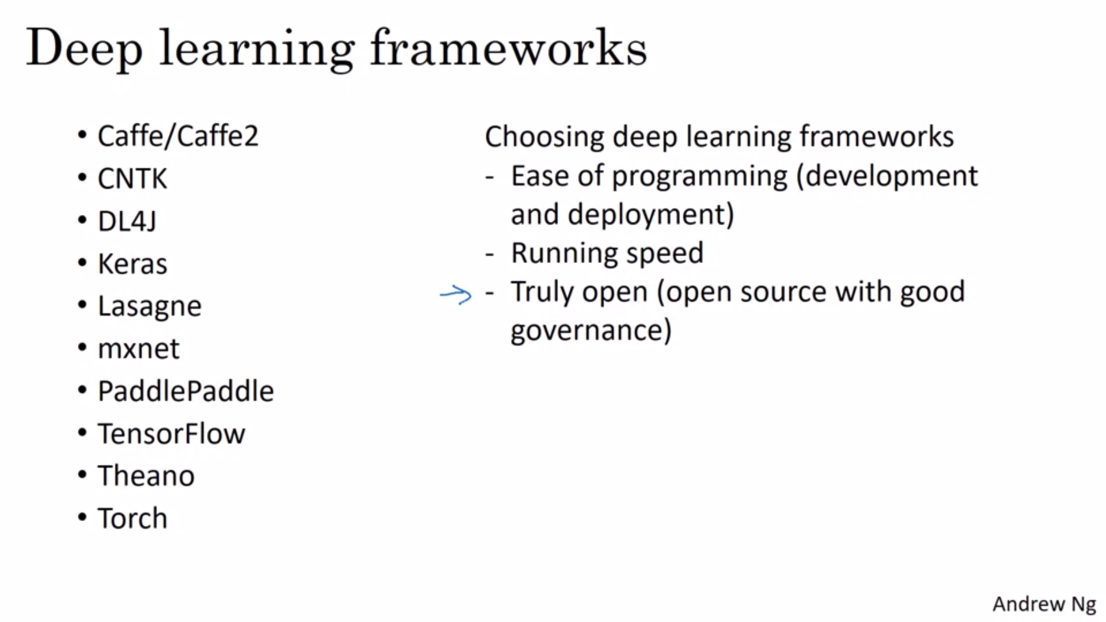

Many different frameworks. These are some of the leading ones. They are evolving and getting better very rapidly.

On the right these are criteria that Andrew wants from a framework.

Truly open means also good governance. Some companies have a history of closing off what was open source originally. How much do you trust that a framework will remain open source.

Programming frameworks provide a high level abstraction.

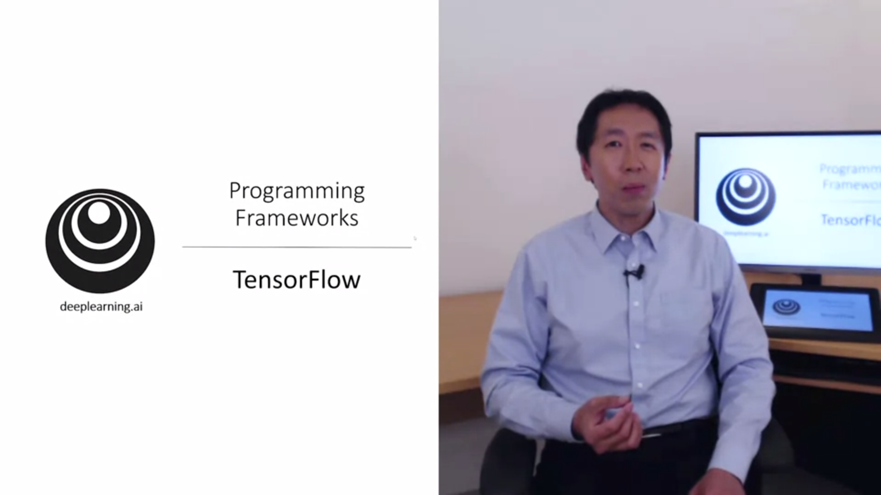

One of the programming frameworks Is tensorflow. Andrew will show us the basic structure.

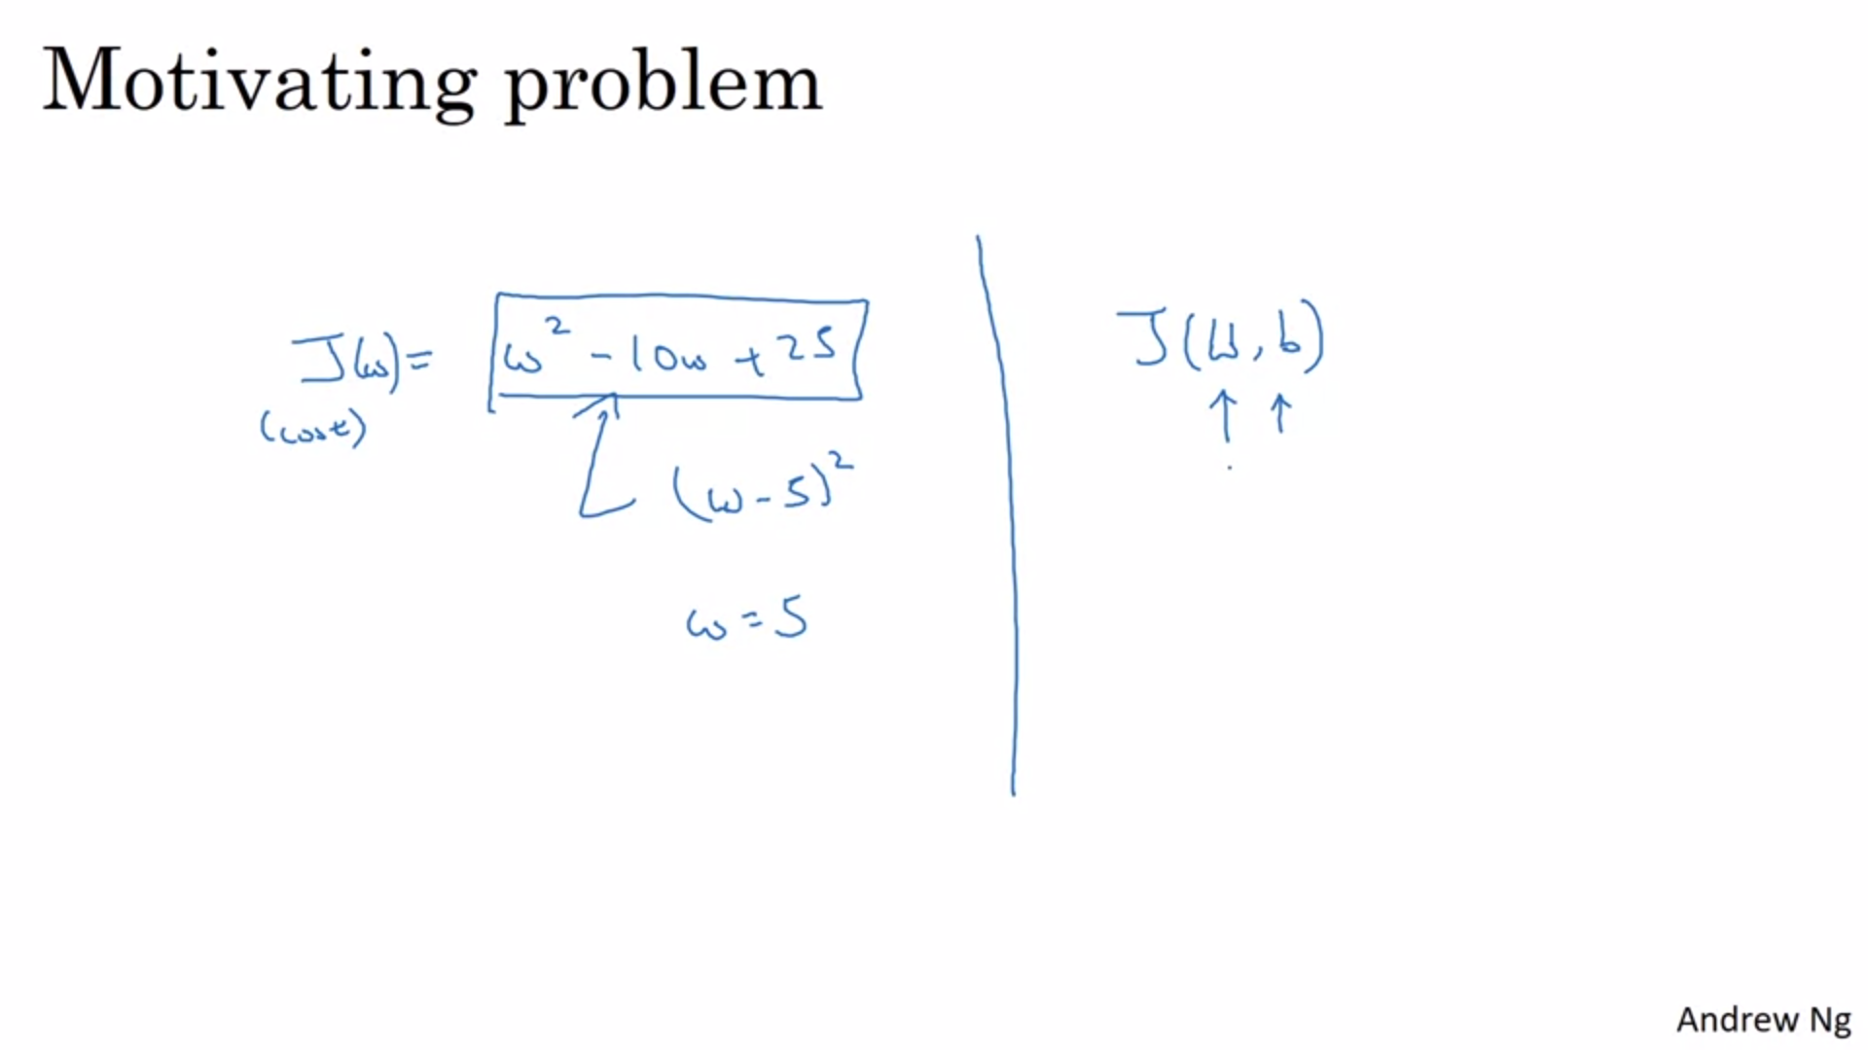

Let’s start with a cost function J and assume we don’t know which w minimizes it.

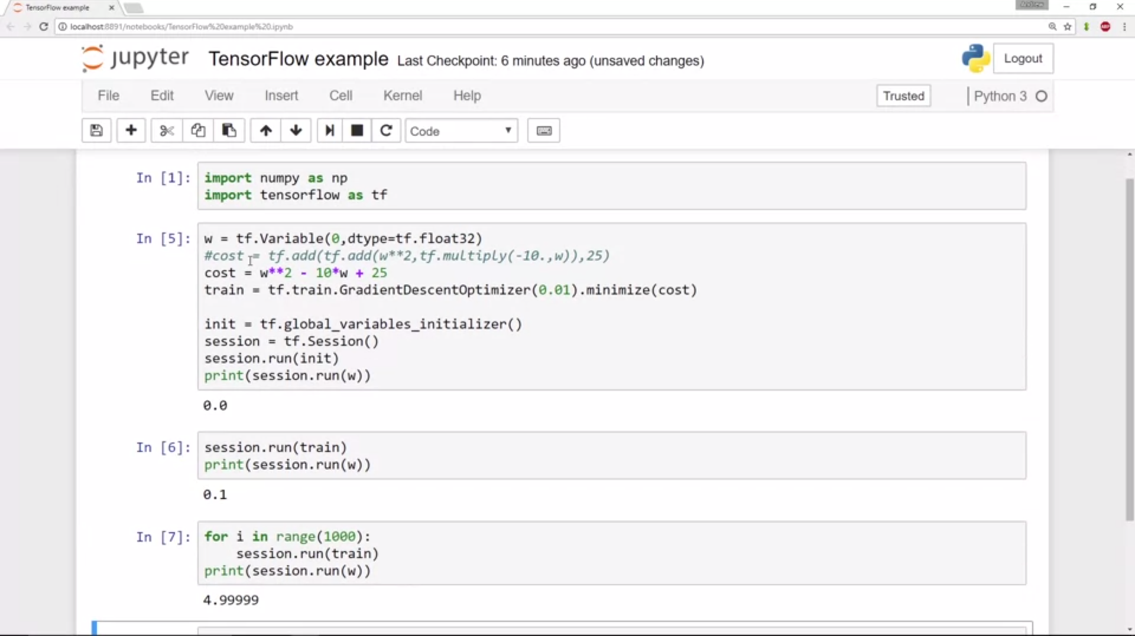

In tensorflow you use tf.Variable to define a parameter.

First define everything, then do one step of gradient descent, then 1000 steps of gradient descent.

W is the variable we want to optimize for: define it as a variable.

Tensorflow knows automatically how to build derivatives and do the backprop.

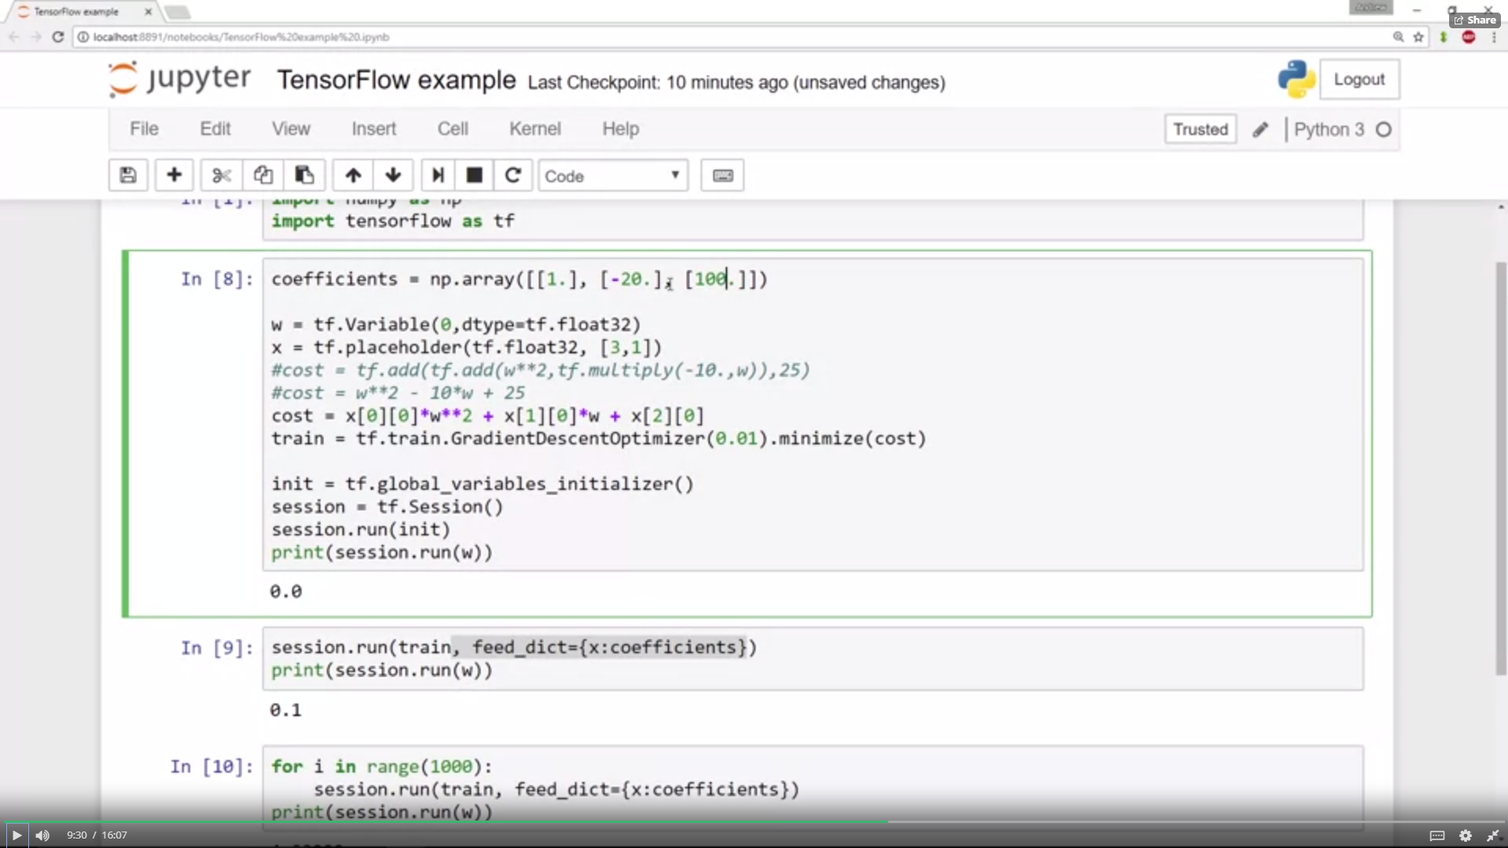

Alternative syntax for cost (works once it is defined as a tensorflow variable).

Now we have optimized for a fixed function w. What if the function we want to minimize is a function of the training data?

X is the training data: define a placeholder.

We turn 1, -10 and 25 into data. Placeholder is something we define the values for later.

Example: coefficient will now be the data that we plug into x. Syntax is feed_dict.

A placeholder is a convenient way to get training data into the cost function.

There are also other optimizers that you can use in 1 line of code.

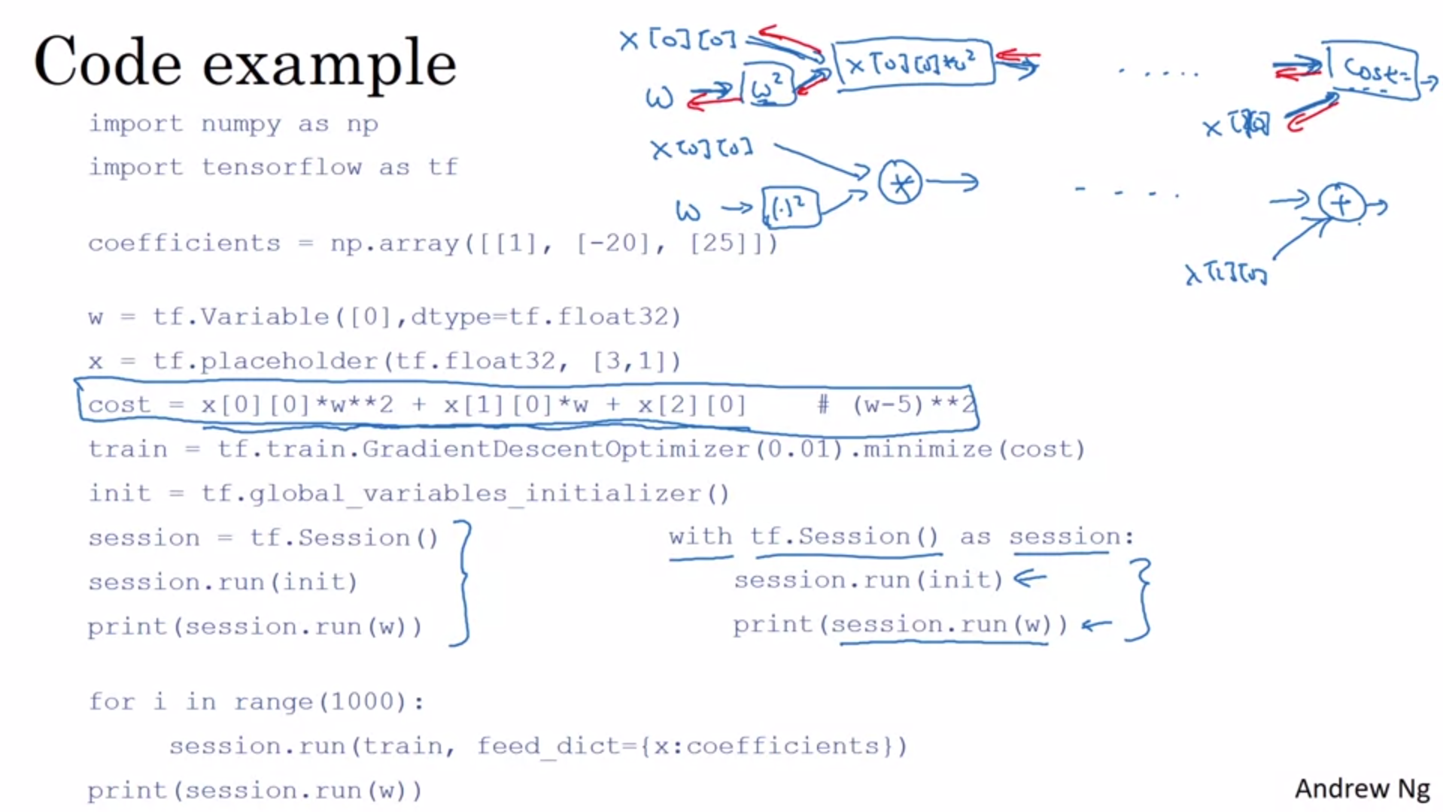

The with construction is an alternative that some programmers use.

The heart of a tensorflow program is to define the cost and tensorflow automatically figures out the derivatives and how to optimize that cost.

We basically construct a computation graph. By using built-in functions to do the forward function it can do the backward pass automatically, even fore complex functions.

All the modern deep learning frameworks support similar things.

This is it for this week. Recap: systematically organize hyperparameter search, batch normalization to speed up training, deep learning frameworks.